FOUNDATION SEMINAR IN SURGERY AND PERIOPERATIVE MEDICINE

Case Study 6: Post-Operative Pain
Prepared by Thuy Bui, January 2019
Reviewed by the SHPA Surgery and Perioperative Specialty Practice Stream Leadership Committee, January 2019
Brennan Fitzpatrick, March 2021

MT a 67-year old female presents for an elective R) total knee replacement (TKR) on the background of osteoarthritis (OA)

Past medical history
- Ex-smoker
- OA – longstanding issue in both knees (R>L) and R) hip; worsening over preceding years and now largely limited to motorised wheelchair; still not adequately managed despite current analgesics
- Gastric banding
- Hypertension
- Ischaemic heart disease
- Obstructive sleep apnoea (uses CPAP)
- 167cm, 130kg

Allergies
- NKDA

Medication history
- Targin 10/5mg BD
- Meloxicam 7.5mg nocte
- Panadol Osteo® 2 tabs TDS
- Endone® 5mg QID PRN
- Perindopril erbumine 8mg mane
- Cholecalciferol 1000units mane
- Magnesium 1 tab nocte

Pre-op bloods
- Secr 52 micromol/L
- eGFR > 90 mL/min/1.73m²
- Hb 131 g/L
- BP 130/74
- O2 sats 97% on RA

You see Ms MT at pre-admission clinic (PAC).

Question 1: What are your recommendations for pre-op management of her analgesics? What additional information would you require from Ms MT or the medical team to assist with your analgesic plan?

Ms MT presents 2 weeks later for her elective R) TKR. You see her post-operatively on the ward and confirm her medications. There are nil changes to her regular medications and she has withheld the meloxicam and perindopril as planned at PAC. She has taken her morning doses of Targin®, Panadol Osteo® and a dose of Endone® prior to coming to hospital.

Medications given intra-op were:
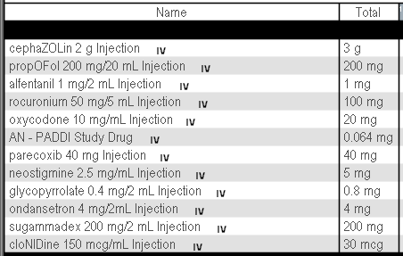
Estimated blood loss 601-1000mL

Question 2: What additional post-op analgesics would you recommend for Ms MT and why?

Day 1 post-op Ms MT is on the below analgesics:
- Oxycodone PCA (69mg in 24 hours, 131 pushes)
- Targin® 10/5mg BD
- Panadol Osteo® 2 tabs TDS
- Pregabalin 75mg BD
Pain scores: 8/10 on movement, 5-6/10 at rest; FAS B. Physio limited by pain, swelling in the R) knee and dizziness. Mainly sitting out of bed and walking to the toilet only. Ms MT had poor sleep overnight due to pain.

Question 3: What analgesics would you recommend and why?

Day 2 post-op Ms MT’s pain is better. Her current analgesics are:
- Oxycodone PCA (15mg in 24 hours, 20 pushes)
- Panadol Osteo® 2 tabs TDS
- Targin® 20/10mg BD
- Meloxicam 15mg daily
- Pregabalin 75mg BD
- Tramadol 50-100mg QID PRN - 100mg x 1 in 24 hours
Pain scores: 6/10 on movement, 4/10 at rest; FAS B. Able to do more with physio today; walked about 15 metres with lots of encouragement but still not ready for discharge from physio’s perspective.

Question 4: What is your analgesic plan and why?

Ms MT is cleared for discharge home 5 days post her R) TKR. Her current analgesics are:
- Panadol Osteo® 2 tabs TDS
- Targin® 20/10mg BD
- Meloxicam 15mg daily
- Pregabalin 75mg BD
- Tramadol 50-100mg QID PRN – 0 in 24 hours
- Endone® 5-10mg q4h PRN - 15mg in 24 hours (2 doses)
Pain scores: 4/10 on movement, 2/10 at rest, pain higher in hip and L) knee; FAS B. Able to walk up a couple of steps and a few trips up and down the corridor with four wheel frame (4WF).

Question 5: What is your analgesic plan for discharge including a weaning plan?

If Ms MT was on Targin® 40/20mg BD pre-op would this change your post-op analgesic management plan?

Question 6: Which analgesics do you think would be appropriate and why?

